Root background--------background: #010424;



background: #010424;



background: #701ABC;

background: linear-gradient(180deg, #00042B 10%, rgba(0, 0, 4, 0.00) 90%, rgba(0, 0, 0, 0.00) 100%);

background: #00063D;

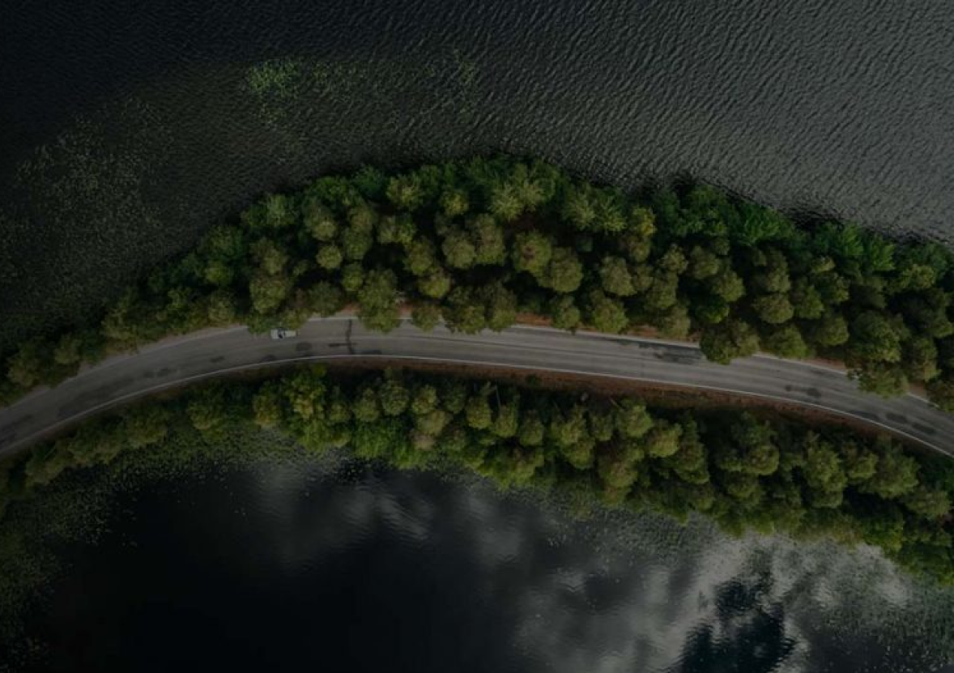











background: #311B61;







**background: linear-gradient(180deg, #00042B 10%, rgba(0, 0, 4, 0.00) 90%, rgba(0, 0, 0, 0.00) 100%);**













**background: radial-gradient(247.68% 51.05% at 50% 50%, rgba(0, 150, 255, 0.33) 0%, rgba(10, 13, 52, 0.50) 17%), radial-gradient(247.68% 51.05% at 50% 50%, rgba(110, 0, 186, 0.50) 0%, #1B1E40 29%), #0A0D34;**



**background: url(<path-to-image>), lightgray 0px 0px / 100% 100% no-repeat;**

**filter: blur(1px);**

**background: #200041;**